**Advance Connect Features Exercise**

Exercise :

* You have to create a simple Shopping Cart Application using React and Redux.
* On the Left, you will have a list of Products, with an Add to Cart button with each of the product. If the product *has* available quantity, it can be added to the Cart, otherwise the button will be *disabled*.
* On the right you will have a Cart section which will display all the products you have added to the cart. It will display the Product *image*, *name*, *quantity added*, *price* for one, and *total price*. You can also *remove* products from the cart.
* As you add a product to cart, it’s quantity will decrease, and if it is removed from the cart, the quantity will increase.
* Style the components as you like. But follow best practices, Container components, Presentational Components etc.
* Use sample products data from here: <https://gist.github.com/manoj-nama/cfa657e318b4d652105b49756c597c76>

Reference Image :

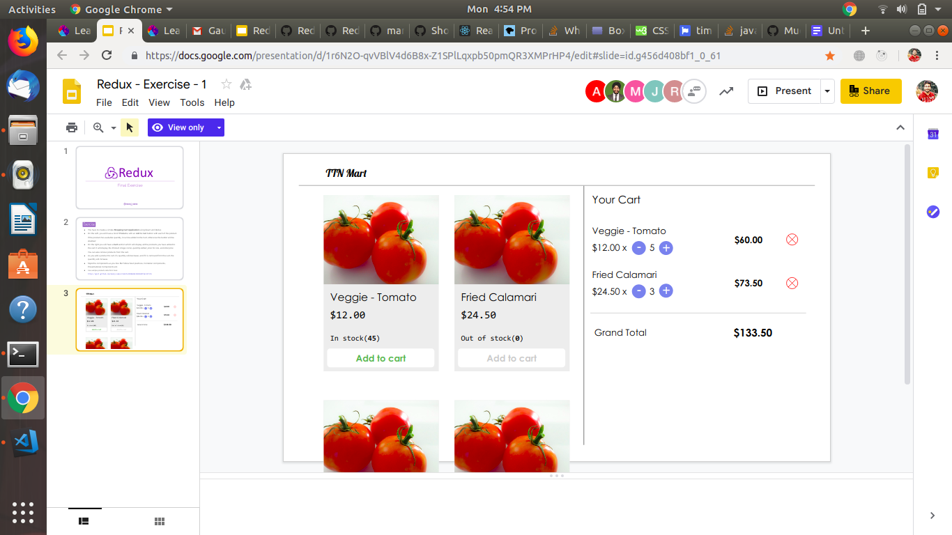

**Solution : please find reduxcart.zip**